AI PROJECT REPORT
Applied AI Engine into a Gomoku Game
Instructor Assoc.Prof. Hai Pham Van¹
Student: Nguyen Khanh Linh 20194789 (Leader)
Bui Tran Hai Quan 20194821
Nguyen Thu Hieu 20194761
Nguyen Minh Tuan 20194876
¹ School of Information Technology and Communication, Hanoi University of Science and Technology, Hai Ba Trung, Hanoi, Vietnam.
² Hanoi University of Science and Technology, Hai Ba Trung, Hanoi, Vietnam.

Abstract. A game of abstract strategy on a board is called Gomoku, also known as five in a row. On a Go board, it is often played by two players, symbolized by the white and black Go stones. On the board, which is represented, players can place stones of their color on vacant intersections via: (row, column). The game ends and the person who has put an uninterrupted chain of five stones wins.
Keywords: Gomoku, game, board, two players, row, column, five stones wins.
- Introduction
The Gomoku game is a classic pastime that has been around for a while. Currently, playing this game online is more common than through a physical board. The use of AI algorithms in the Gomoku game will increase player efficiency and result in smart moves, allowing players to unwind after a long day at the office and raise their Gomoku skills.
- The proposed model
Gomoku game program using Turtle in python and AI engine based on minimax algorithm, alpha-beta pruning along with 4-way score heuristic.
Algorithm
Analysis: The game can be represented as a root tree, nodes, leaves and branches:
. Root is the initial state of the game. For each particular game, the state (at each point) is characterized by its own parameters
. The nodes of the tree represent the current state of the game, including parent and child nodes.
. Branches connecting nodes represent moves, i.e. indicate from one situation of the game to another through a single move.
. The cards, also known as leaf nodes, represent the end of the game when the outcome of the game is known.
. Tree depth: Number of floors of the tree
Each end game position (leaf node) assigns a weight. ex: 1 win, 0 draw, -1 lose. At each node there is also a corresponding weight determined in some way. Based on this game tree, we can find good moves to win.
After each move, the number of empty cells will decrease. Therefore, the search for the next move is the search in the space of the remaining empty cells, after each turn, the search space will decrease. The move search strategy is to choose a node in the tree such that the move is good. And to evaluate that node, we have to look at the depth of the tree. Because the search space is too large, we limit the computer to only search at a certain depth. The deeper the program, the better it plays, but it will pay the price in terms of time.
  - Minimax algorithm
2.1.1 Overview

Minimax is a decision rule widely used in game theory for minimizing the possible loss for a worst case scenario, which ,technically speaking, means the maximum loss. Likewise, it is referred to as "maximum" , to maximize the minimum gain when dealing with gains. In the field of zero-sum games the maximin rule or strategy states the following: The best possible play for player 1 in a given state is the the one that minimizes the best possible play for player 2 from that state; This means that we can conceive an algorithm that calculates the best possible play from a given state by looking for the worst best possible play from all of the possible subsequent moves. Of course this does not apply for terminal moves, that is, moves where the game ends, where their value is simply the outcome of the game in that particular state.
2.1.2 Minimax algorithm with alternate moves

A minimax algorithm is a recursive algorithm for choosing the next move in an n-player game, usually a two-player game. A value is associated with each position or state of the game. This value is computed by means of a position evaluation function and it indicates how good it would be for a player to reach that position. The player then makes the move that maximizes the minimum value of the position resulting from the opponent's possible following moves. If it is A's turn to move, A gives a value to each of their legal moves.

  - Alpha-beta pruning algorithm.
2.2.1 Overview

Alpha–beta pruning is a search algorithm that seeks to decrease the number of nodes that are evaluated by the minimax algorithm in its search tree. It is an adversarial search algorithm used commonly for machine playing of two-player games. It stops completely evaluating a move when at least one possibility has been found that proves the move to be worse than a previously examined move. Such moves need not be evaluated further. When applied to a standard minimax tree, it returns the same move as minimax would, but prunes away branches that cannot possibly influence the final decision.

2.2.2 Core ideas

The algorithm maintains two values, alpha and beta, which represent the minimum score that the maximizing player is assured of and the maximum score that the minimizing player is assured of respectively. Initially alpha is negative infinity and beta is positive infinity, and both players start with their worst possible score. Whenever the maximum score that the minimizing player(beta) is assured of becomes less than the minimum score that the maximizing player(alpha) is assured of (beta <= alpha), the maximizing player need not consider the descendants of this node as they will never be reached in actual play.

2.3 Pseudocode
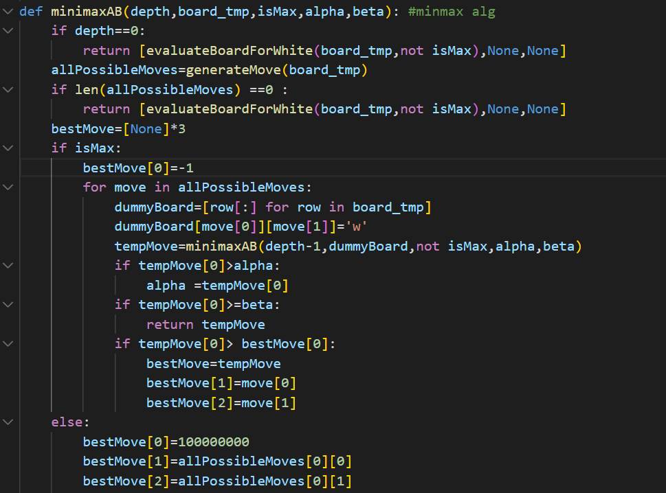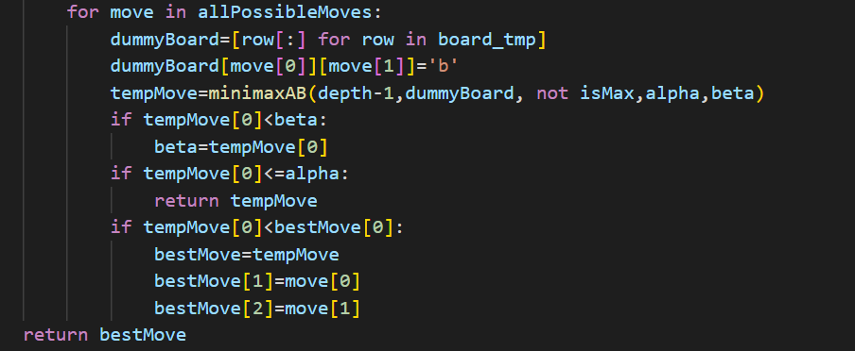

2.4 . Heuristic Evaluation Algorithm

To gain better performance in move selection ,it is important to build an heuristic algorithm to reduce the computational cost .The heuristic evaluation function should consider both offense and defense scores for the next possible move on the board. Follow the idea from [5] we have build a simple formula to calculate the evaluation score :
$$evaluation score=\frac{score of Maximizing player}{score of Minimizing player}$$

The more chance of win a move can bring to the player , the more score that move can get .That means if a move can create many consecutives, in many directions(vertical,horizontal, diagonal) and these consecutives are not blocked by the opponent ,it can gain a very high score. Below is the table illustrate how we calculate score of X in case the current turn belong to X
Pattern a move make | Score | Explaination
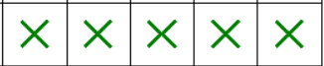 | 100000 | Maximum score since the move create 5 consecutive and win the game
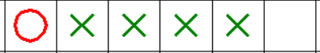 | 200 | To prevent X win O in the next move need to fill in the remaining right space
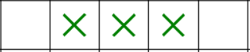 | 200 | This move bring more chance for X to offense since there is no block
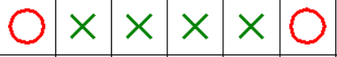 | 0 | This move have no meaning since X is block in both side

Notice that we will calculate score for X base on every pattern that X makes in every direction (horizontal,vertical and diagonal)
In case of O if O has a move that bring many consecutives(lead score of O increasing) and also somehow block X, lead score for X decreasing that will make the total evaluation score become smaller. That is also the aim of O : try to make the evaluation score smaller

2.5 Our distribution:
a. Try to reduce space
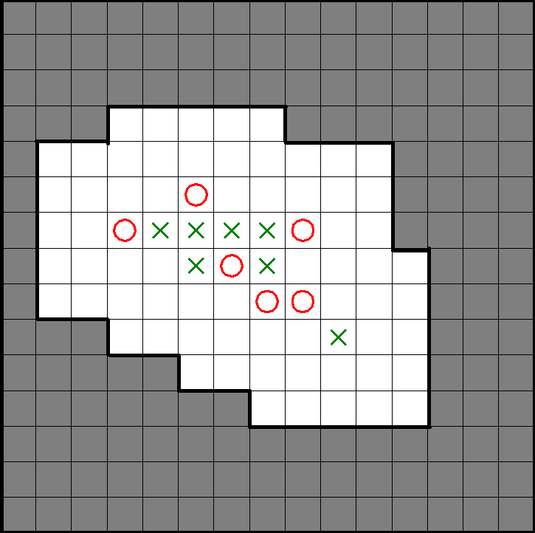

If we consider all the move, it can lead to a very heavy computational cost. So we try to downscale the space to only 2 squares that consecutive to all current square that have X and O
Bellow is our piece of code to implement generate move that only consider most valuable move:
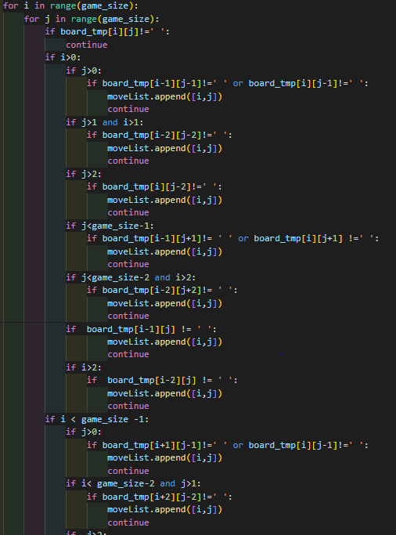

b. Consider discontinuous pattern.
One of the limit of [5] is that the code can not consider discontinuous offense pattern.
We try to implement new function to consider this pattern
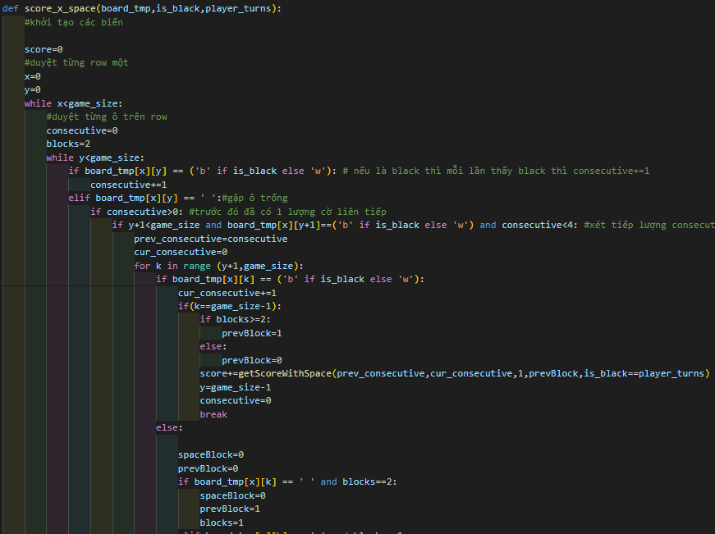

Pattern | Old algorithm | New Alorithm
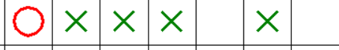 | 3 consecutive with one blocks+1 consecutive  =200 + 1 =201 points | 1000 * 0.9 points

- Performances

This section shows the performances of both AI player on the same scenario: make a move based on the current board. The AI player with alpha-beta pruning is able to make a prediciton within 0.766 1 seconds for depth 3 and 6.932 seconds for depth 4. The runtime of the parallel AI is shown in Table 1. The results show that the parallel implementation is able to speed up the process significantly:
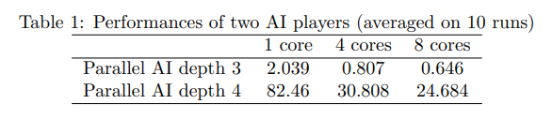
running in 4 cores, the run time is less than half of the run time in 1 core. However, the run time of the alpha-beta pruning AI is significantly better than this parallel implement
- References
[1] 3 Simple Ways to Play Gomoku - wikiHow
[2] Gomoku - Wikipedia
[3] Minimax - Wikipedia
[4] Alpha–beta pruning - Wikipedia
[5] https://github.com/canberkakcali/gomoku-ai-minimax

